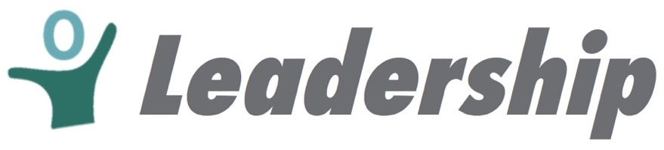
CEELO LEADERSHIP ACADEMY
Face-2-Face Meeting – Timed Agenda
Westin Long Beach, CA

WEDNESDAY – May 29, 2019
Time | Lead | Topic | Desired Results
8:30am-9:00am | Tracy/Jana | Welcome, Introductions | Welcome new fellows and former fellows. Introduce yourself and provide reflection.
9:00am-9:45am | Jana/Tracy | 6 Core Competencies | Review 6 Core Competencies of Leadership Academy. Specifically introduce Equity as focus for this cohort.
9:45-am-10:45am | Two former fellows to lead | Leadership on the Line & Previous Readings | Discussion of the readings from Leadership on the Line. Ask former fellows to also reflect on the readings and if having re-read it –did it resonate differently?
10:30am-11:15am | Deb and Tracye | Ellen Frede & NJ Panel | Discuss NJ’s work leading toward results through the frame of Leadership Academy competencies.
11:15am-12:00pm | Lori | Legacy Project | Review the findings of the Legacy Project. Break into small groups and consider “So What – Now What?” Fellows draft a set of recommendations.
12:00pm-1:00pm | All | Lunch - discussion | Share out from the previous sessions during lunch.
1:00pm-1:30pm | Jana | Walkabouts with guided questions | Pair/Share – Adaptive Leadership 1st group pair new/former
1:30pm-2:00pm |  | Walkabouts with guided questions | 2nd group Pair/Share – Job-Embedded Projects.
2:00-2:50pm | Lori/Tracy | Shannon Christian/ Aaliyah Samuel | Discuss experiences of technical vs adaptive leadership, risk taking & innovation, equity. Q&A from fellows.
2:50 | Tracy/Jana | Check-out | Get ready for 3:00 meetings, Reception and Roundtable

