CEELO LEADERSHIP ACADEMY
Leadership for Results
August 8-9, 2018

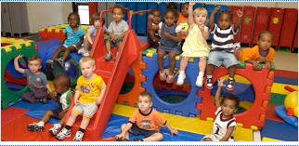

Data Tour Guide

Pair with someone. Walk around the room together, look at the posted information, and answer the following questions:

- What is the current state of early childhood learning as reflected in the data?

- What do you notice about the connections between the work you are doing and the work others are doing?

- Is essential data present? If not, what is missing?

- How does what you see make you feel?

