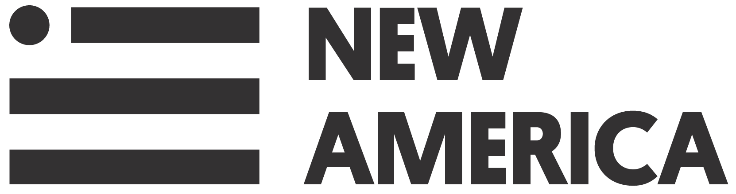
CENTER ON ENHANCING EARLY LEARNING OUTCOMES
___________________________________________________

Looking for Writers to Share ESSA Implementation Insights and Experiences
Blog series - One Year Later: From Plans to Actions on ESSA Implementation

Building on New America and CEELO’s ESSA blog series that ran last summer on early childhood policy priorities addressed in State Education Agencies’ ESSA plans, this summer we plan to explore next steps and implementation of ESSA plans with a focus on early childhood policy. We plan to highlight progress made, one year later, in five areas: school quality indicators, school improvement, data and transparency, educator support, and family engagement and transitions.

We invite state, national or local leaders to write about ESSA implementation efforts at the state or local level to help increase awareness of early successes, and identify any emerging obstacles and possible solutions. Our goal is to elevate learning’s from state and local leaders as they work to act on the goals, objectives, and strategies related to early education, for children birth through third grade, included in the ESSA plans.

If you are interested in writing about 600-800 words for the blog series or can identify someone else to write, please fill out the form below. If you have any questions please email Laura Bornfreund bornfreund@newamerica.org or Lori Connors-Tadros at ltadros@nieer.org.
——————————————————————————————————————-
ESSA Implementation Blog Series Interest Form

Name:
Email:

Topic area (select one):
school quality indicators
school improvement
data and transparency
educator support
family engagement and/or transitions
other topic that you suggest, please describe:

We will begin the series in on Tuesday, September 4th and will publish a blog every other Tuesday until Dec 18, 2018. Please check the month when you will submit your draft for publication.
September October November December

Michelle Ruess, NIEER communications director, will be in touch with you to confirm your contribution and assist you in drafting and editing the blog. We greatly appreciate your interest in elevating great examples of how states and communities are addressing early learning in ESSA!

