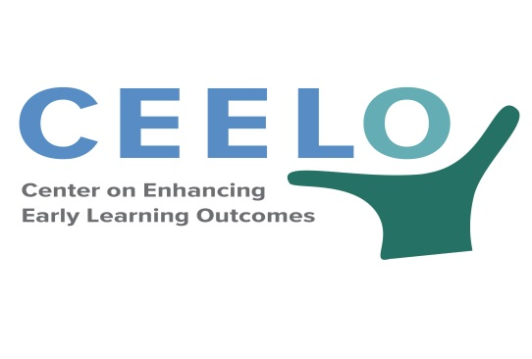
COST OF QUALITY EARLY LEARNING THINK TANK
Note Taking Form
DAY 1| May 16, 2018 2:30-3:00
Purpose and Context of the Meeting
Lori Connors-Tadros and Theresa Hawley

With your colleagues discuss the following three questions:

1. What is the one cost/financing issue that is keeping you up at night?

2. How would things change if this issue was resolved?

3. What’s at risk? What would happen if we don’t address this issue?

DAY 1| May 16, 2018 3:00-4:30
Anchoring our Discussion in Reality: Kentucky and Chicago
Kentucky: Cory Curly, Carlena Sheeran, Margaret Hulbert
Chicago: Samantha Aigner-Treworgy and Kate Ritter
Moderator: Theresa Hawley

Notes from this session:  How do the purpose, goals and intended uses of cost data drive the process?  What are the most effective approaches to gathering accurate data? developing buy-in?  What are the “early returns” from cost modeling processes for policy/systems development? | Aha! Moments
People I want to follow-up with during the Think Tank (either I want to share something or I need more info) | After the Think Tank…

DAY 2| May 17, 2018 8:50-10:30
What Do We Know about collecting cost data that reflects true costs of quality given the realities of early learning systems at the state and local level?
Moderator: GG Weisenfeld
Facilitated Discussion: George Rickus, 3SI, Garrison Kurtz, WA, Simon Workman, CAP

Notes from this session:  Are there core principles of collecting and using cost data to inform policy?  What are the “true” costs of quality, how do we get this data?  How can cost studies more accurately reflect the realities of early learning systems at the state and local level? | Aha! Moments
People I want to follow-up with during the Think Tank (either I want to share something or I need more info) | After the Think Tank…

DAY 2| May 17, 2018 11:00-12:15
What Gets In The Way of adequate and stable funding at the state and local level?
Moderator: Lori Connors-Tadros
Facilitated Discussion: Steve Barnett and Lynn Karoly

Notes from the session:  How can we increase the use of valid cost data in evidence-based policy?  How does a state that wants to efficiently fund quality programs do the best job of making the right choices?  What gets in the way of allocating resources to programs to support sustainable and stable funding? | Aha! Moments
People I want to follow-up with during the Think Tank (either I want to share something or I need more info) | After the Think Tank…

DAY 2| May 17, 2018 1:00-2:30
What Is Needed to communicate and influence funding decisions to support access to high quality early learning programs?
Moderator: Tracy Jost
State Sparks: Lisa Backer, MN, Dana Hepper, OR Children’s Institute
Advocacy Spark: Albert Wat

Notes from the session:  Do cost studies lead to policy changes or are they purely an academic exercise?  What information do policy makers need to make informed decisions, and what information do we need for advocacy? Do we confuse these two needs?  How can we best leverage the communication materials created to advance individual state and national advocacy? | Aha! Moments
People I want to follow-up with during the Think Tank (either I want to share something or I need more info) | After the Think Tank…
DAY 2| May 17, 2018 2:45-3:45
What’s Next to drive policy and funding decisions on financing for high quality early learning programs?
Moderators: Lori Connors-Tadros and Theresa Hawley

Notes from the session:  What are the Top 5 “shared understandings and principles” of addressing costs in evidence-based policy?  What are the Top 5 capacities, research and tools needed in the next 1-3 years to increase adequate and stable funding for high quality early care and education? | Aha! Moments
After the Think Tank…

Participant | Notes
Samantha Aigner-Treworgy
Lisa Backer
Steve Barnett
Kelli Bohanon
Lori Connors-Tadros
Megan Cox
Cory Curl
Ellen Frede
Karin Garver
Rebecca Gomez
Rolf Grafwallner
Theresa Hawley
Dana Hepper
Margaret Hulbert
Nina Johnson
Tracy Jost
Lyn Karoly
Garrison Kurtz
Katy McCullough
Sara Mickelson
Anne Mitchell
Sandra Myers
George Rickus
Kate Ritter
Jessica Roach
Michelle Ruess
Carlena Sheeran
Linda Smith
Helene Stebbins
Bryan Stokes
Sara Vecchiotti
Teresa Waite
Albert Wat
Maria Whelan
GG Weisenfeld
Simon Workman
Amanda Zimmerman

