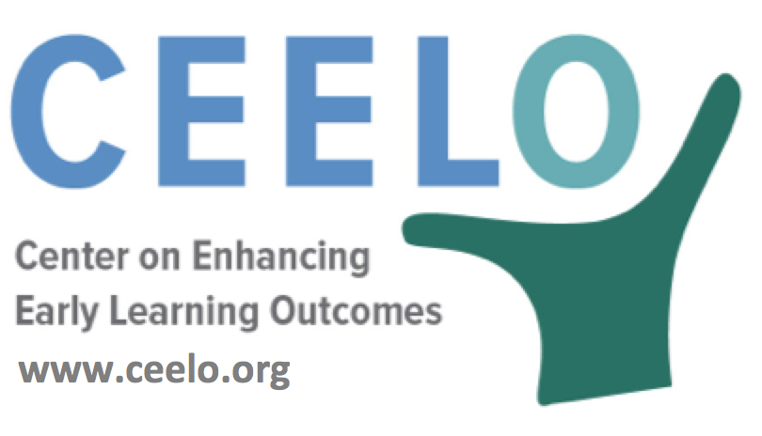

How to Talk about Pre-K Costs

With early learning, you get what you pay for. Research shows investing in the early years of a child’s life often produces a high rate of return by positively impacting a child’s readiness at kindergarten entry and future success in elementary school, high school, college, and adulthood. But that doesn’t make it easy to obtain the funding to provide the high-quality experiences children need to thrive and succeed in school and in life.

These messaging tips, along with resources and talking points, can help you put costs in perspective and show why high-quality preschool is one of the best investments we can make.

Messaging Tips

- Don’t talk about costs. Talk about benefits and value.
  - High-quality preschool enrollment creates education and social savings: Children arrive at kindergarten ready to learn, less need for special education, lower grade retention rates, higher reading scores, higher graduation rates, better-paying jobs, and lower crime rates. (see The Current State of Scientific Knowledge of Pre-Kindergarten Effects report from The Brookings Institute)
  - Safe, reliable high-quality early childhood programs enable parents to find better jobs and boost family income, especially for single-parent households. (see How to Improve Economic Opportunity for Women from AEI Research)
  - Early education is a sound use of public dollars. (see The Benefits and Costs of Investing in Early Childhood Education from the Washington Center for Equitable Growth)
  - Cost-benefit analyses have shown for every $1 invested, more than $10 is returned in cost savings—an inflation-adjusted annual return on investment of 18% over a child’s lifetime, cumulative return of 900% (see “Want to Beat the Stock Market?”)

- Always use the phrase “high-quality preschool” or “high-quality early learning”
  - Explain how quality teaching nurtures cognitive and social-emotional development.
(see CEELO policy report Early Childhood Teacher Education Policies)
  - Explain that lack of positive experiences or negative experiences can result in serious consequences in children’s learning and wellness. (see The Science of Child Development and Learning brief from US Administration on Children and Families)

- Use science to explain why early learning is so important
  - In early childhood, brain development is strongly influenced by environment and experiences.
  - Early experiences affect the development of brain architecture, which provides the foundation for all future learning, behavior, and health. (Harvard University Center on the Developing Child)
  - Early experiences deeply affect a child’s physical, cognitive, emotional and social development.
(see Encyclopedia on Early Childhood Development)

- Collect and share one or two true stories about the benefits of high-quality early learning
  - Reach out to early childhood program directors for real-life examples of children who gained new vocabulary, social emotional skills, or academic skills needed for Kindergarten. Stories engage an audience emotionally and enable you to issue a call to action.

- Use CPQ to create graphs that illustrate costs associated with implementing high-quality preschool
  - Policymakers are busy! Use graphs to make the impact of various early learning options easy to understand
- Visit National Conference of State Legislatures Early Care and Education for state policy updates
  - Highlight early learning opportunities available to young children and families in neighboring states. How do your policies and investments compare?
  - Use successful state programs as a “how-to” guide for enhancing early learning opportunities: how to finance and how to implement new policies

