Sample CPQ Graphics

These figures provide suggestions for graphically illustrating key policy questions associated with high-quality preschool programs using the CPQ calculator. To create your own graphs, please visit the CEELO webpage and click on User Guide.
Example 1: Per Child Costs
High-quality early education benefits all children. The CPQ calculator can help you show policymakers the investment needed on a per-child bases to enhance quality in specific ways, such as enhancing teacher degree requirements, reducing class size and increasing dosage.

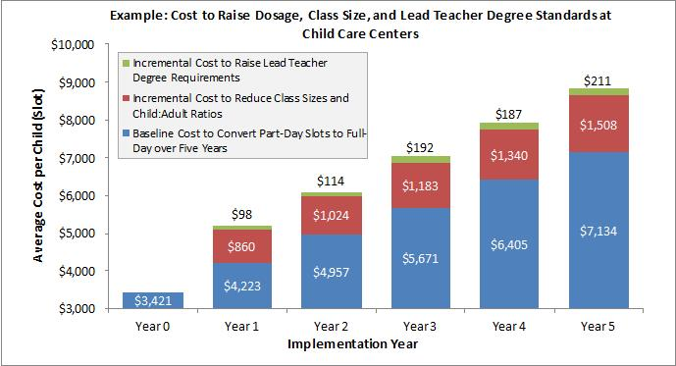

Example 2: Teacher Salaries & Benefits
High-quality pre-k is one of the best investments we can make with public dollars—and teachers are key. The CPQ calculator can help you illustrate teacher salary and benefits, often the greatest investment for any pre-K program.

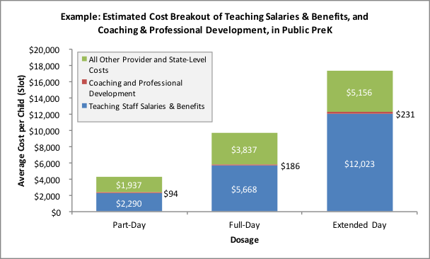

Example 3: Average Spending per Child
Studies show rates of return exceeding costs for every dollar invested in high-quality pre-K and that dosage greatly affects child outcomes. The CPQ calculator can help you explain how spending per child varies by the length of day the child attends a program.

Example 4: Costs of Increasing Pre-K Teacher Credential Requirements
Teaching pre-K requires specialized skills to help each child learn and grow. The CPQ calculator can help you show policymakers the financial investment needed to enhance teacher credential requirements.

Example 5: Per Child Cost Based on Class Size, Student-Teacher Ratio
Young learners need small classes and one-on-one time with teachers. The CPQ calculator can help you illustrate the investment needed to reduce class size and student-to-teacher ratios.

