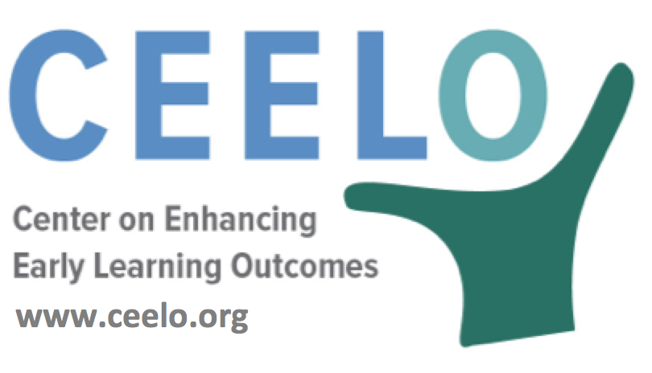
Why Quality Matters in Pre-K:
Continuous Quality Improvement Systems Learning & Development Standards

Just as we encourage children to master new skills, we expect adults to improve and enhance their own professional skills. To ensure public pre-K programs are as effective as possible, a system to assess program quality and external accountability is essential. Beyond monitoring programs, a continuous quality improvement system (CQIS) requires that each classroom receives an annual structured observation of classroom quality in order to gauge quality on a valid and reliable measure, and critically, information from the observation is used to help teachers improve their classroom practices.

Implementing a CQIS requires the use of a structured classroom observation tool. The three greatest cost drivers are the conducting of the assessments; establishing a system to ensure the reliability of the observations; and developing a system to collect and share the data with the pre-K program. It is recommended that classrooms be assessed annually to increase the probability that ratings would be valid given the high staff turnover in early childhood programs. Assessors are either employees of the state or contracted by the state to conduct observations. Even if they are contracted by the state, it is assumed that the state allocates resources to oversee the activities of the third party for quality assurance purposes.

To guarantee the reliability of the assessments, the person conducting the observations must be trained to reliability which may be an additional cost for the state. Even if the state is not providing the trainings, costs associated with assessor’s reliability testing or a data system to maintain assessors’ qualifications and status may be incurred by the state.
Did you know…
“Beyond monitoring programs, CQIS requires that each classroom receives an annual structured observation of classroom quality in order to gauge quality on a valid and reliable measure, and critically, information from the observation is used to help teachers improve their classroom practices.”
–The State of Preschool 2016
- “Continuous improvement” is an attitude that avoids blame and encourages excellence, teamwork and creativity.
- A CQIS codifies these attributes in practices that can be assessed and adjusted to enhance early learning outcomes.
- Research suggests CQIS can improve classroom quality and lead to positive child outcomes by focusing on active supports for good teachers to provide engaging, intentional and individualized education for every child.
To learn more:
A Blueprint for Early Care and Education Quality Improvement Initiatives
Kathryn Tout, Dale Epstein, Meg Soli, and Claire Lowe (2015)

childtrends-ciw49tixgw5lbab.stackpathdns.com/wp-content/uploads/2015/03/2015-07BlueprintEarlyCareandEd1.pdf

