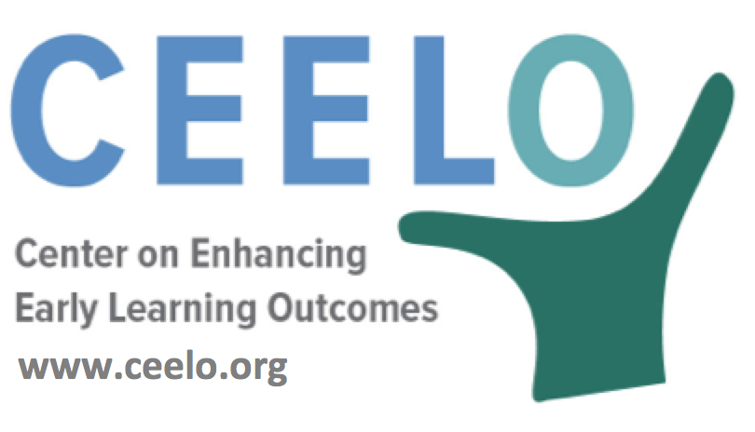
Why Quality Matters in Pre-K:
Early Learning & Development Standards

Early learning and development standards (ELDS) are critical to quality, offering programs guidance and helping ensure the full range of areas essential to children’s learning and development is addressed. In 1991, the National Education Goals Panel identified five areas of child development comprehensive standards: children’s physical well-being and motor development, social/emotional development, approaches toward learning, language development, and cognition and general knowledge.

To be useful, ELDS should be tailored to educating preschool-aged children, appropriate for their level of development as well as vertically aligned with state standards for both infant and toddler care and early elementary grades such as K-3 standards--which in turn should be aligned with state academic standards or career and college-ready standards.
These standards should be responsive to children’s diverse cultural and language backgrounds, and horizontally aligned with child assessments and curriculum implemented in the pre-K classroom. In order to support the use of the ELDS, pre-K programs need to have access to resources along with professional development opportunities. Support is needed for selecting or adopting curriculum that is aligned with the ELDS and then guidance for curriculum implementation with fidelity may come in the form of teacher training, ongoing technical assistance, or additional funding.
“Today, educators and leaders are faced with the challenge of building a developmentally appropriate primary school without sacrificing the academic rigor needed to support young children in achieving success in school and beyond.”
– NIEER Associate Research Professor Shannon Riley-Ayers, Ph.D.

Did you know…
- Learning and Development Standards should cover multiple domains of learning, be aligned with both K–3 or college & career ready standards and infant and toddler standards, consistent with child assessments, supported though professional development and/or additional resources, and culturally sensitive.

- Cultural sensitivity is key to creating a welcoming environment, teaching respect for diversity, supporting children’s ties to their families and community, and promoting second language acquisition and preservation of children’s cultural identities.

To learn more:
Child Outcome Standards in Pre-K Programs: What Are Standards; What Is Needed to Make Them Work?
Elena Bodrova, Deborah Leong and Rima Shore (March 2004)
http://nieer.org/policy-issue/policy-brief-child-outcome-standards-in-pre-k-programs

