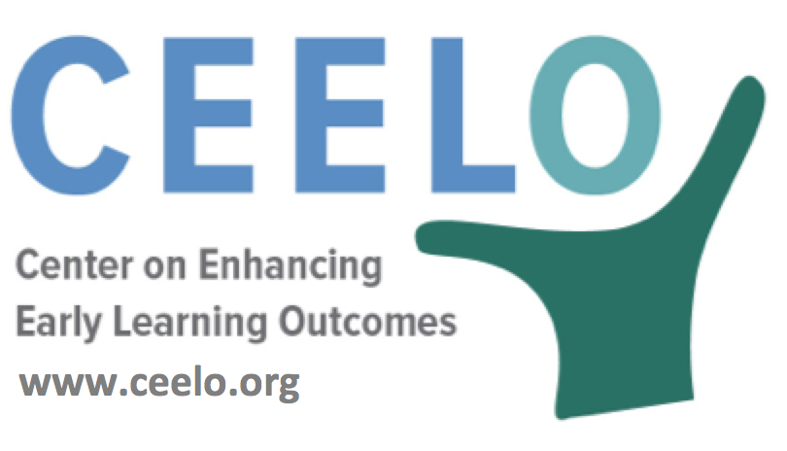

Why Quality Matters in Pre-K:
Class Size, Student-Teacher Ratios

For young learners, smaller class sizes and lower staff-child ratios create conditions needed for increased levels of high-quality social and instructional interactions. A large body of literature establishes linkages between staff-child ratio, program quality, and child outcomes. With smaller classes and fewer children per teacher, children have greater opportunities for interaction with adults and can receive more individualized attention, resulting in increased learning that leads to better student outcomes.

Early education programs that have been evaluated and found to be effective all limit class sizes to fewer than 20 with teacher to child ratios of 1 to 10 or lower, including Boston’s Public School Prekindergarten Program, New Jersey’s Abbott Preschool Program, and Oklahoma’s Early Childhood Four-Year-Old Program. Small classes enable teachers to have more individual contact with each student and increase the likelihood of implementing differentiated teaching methods, resulting in meeting each student’s unique developmental needs.
“Teaching young children requires immense energy and relentless attention. When there are fewer children in the room, the teacher has more time to devote to each child, and managing the group requires less teacher time.
As a result, teachers have opportunities to have longer conversations with each child.”
– W. Steven Barnett, Ph.D., Senior Co-Director, National Institute for Early Education Research
Did you know…
- Smaller class size encourages intentional teaching that is child-centered.

- Teachers can provide more individualized attention, and engage in more dialogues with children—key factors in academic and social development.

- In smaller groups, child-initiated activities that foster creativity and vocabulary are more common rather than teachers managing the class by directing or scheduling activities. (Eager to Learn, National Research Council)

- Low wages and limited opportunity for professional development and support often leads to high rates of teacher turnover. High teacher turnover has been found to negatively affect children's social, emotional, and language development
To learn more:
Class Size: What’s the Best Fit?
W. Steven Barnett Ph.D., Karen Schulman and Rima Shore (December 2004)
nieer.org/policy-issue/policy-brief-class-size-whats-the-best-fit

