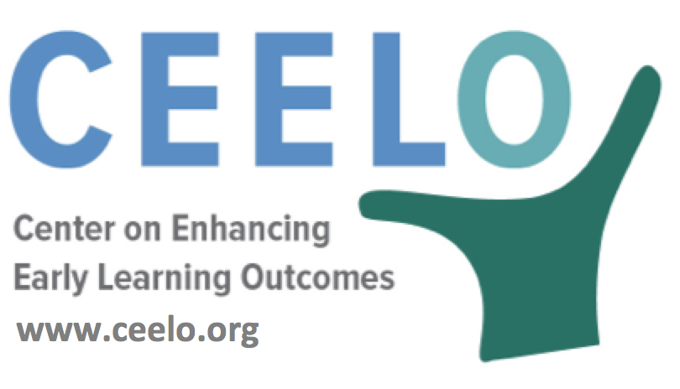

Why Quality Matters in Pre-K:
Teachers

Pre-K classrooms are typically supervised by a lead teacher and an assistant teacher. Research has shown these adults play a crucial role in each child’s academic and social/emotional development. The design and management of the classroom and how teachers interact with children make a big difference in child outcomes. High-quality preschool--and positive outcomes for children-- depend on knowledgeable, dedicated teachers and effective administrators.
Based on a review of the evidence, a committee of the Institute of Medicine and National Research Council of the National Academy of Science recommended lead preschool teachers have a bachelor’s degree with specialized knowledge and training in early childhood education. There is not much research on the qualifications of assistant teachers; however, the Child Development Associate (CDA) credentialing program has been recommended to help prepare assistant teachers to become teachers rather than permanent assistants.

Qualifications for teaching roles vary, but ongoing support is required. Effective pre-K teachers who are engaged with children in their teaching practices are also actively engaged in continuing professional development. The national standard, developed by the National Institute for Early Education Research, recommends more than 15 hours of training annually with no more than 50 percent focused on health and safety. In addition to training, coaching or ongoing embedded classroom support based on classroom observation is necessary to enhance teaching practices and provide high- quality, effective learning experiences for children.
“Young children’s learning and development depend on the educational qualifications of their teachers.”
– Diane Schilder, Ed.D., Principal Research Scientist, Education Development Center
Did you know…
- Good preschool teachers don’t just focus on academics, but support each child’s physical, cognitive, social, emotional, and moral development in partnership with parents.
- According to U.S. Department of Labor (2016), the median hourly wage for preschool teachers is less than $14.
- Low wages and limited opportunity for professional development and support often leads to high rates of teacher turnover. High teacher turnover has been found to negatively affect children's social, emotional, and language development.

- Low wages and limited opportunity for professional development and support often leads to high rates of teacher turnover. High teacher turnover has been found to negatively affect children's social, emotional, and language developme
To learn more:
Early Childhood Teacher Education Policies Research Review and State Trends
CEELO Policy Report April 2016
ceelo.org/wp-content/uploads/2016/04/ceelo_policy_report_ec_teach_education_policies_final_for_web_2016_04.pdf

