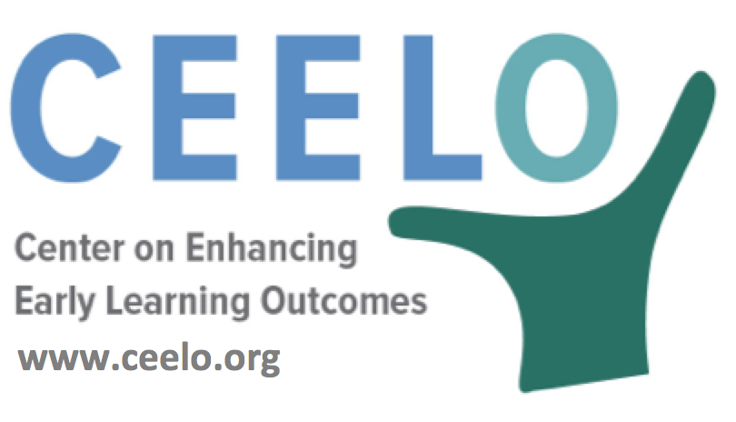

Why Quality Matters in Pre-K:
Benefits

Spending on many state preschool programs is currently quite low; not surprisingly, so are the outcomes. Three of the four states with the largest populations of 3- and 4-year-olds rank near the bottom on quality standards and spending per child. In 2015-2016, average pre-K state spending was $4,976 per child nationwide. In this same year, 32 percent of 4-year-olds and 5 percent of 3-year-olds were served nationally.

Research shows investing in the early years of a child’s life often produces a high rate of return by positively impacting a child’s readiness at kindergarten entry and future success in elementary school, high school, college, and adulthood. Jim Minervino (2014) created a series of research papers that addresses the conditions and costs associated with implementing high quality pre-K. Through his analyses of published research, program evaluations, and “extensive consultation with experts in the early childhood field,” Minervino concluded that there are substantial funds already invested in early learning, however focusing on different practices and policies could yield better results.

James Heckman’s analysis of the Perry Preschool program, the original longitudinal study that proved quality early childhood education has a lasting and positive impact on participants into, found a 7 to 10% return on investment. A re-analysis of the Perry Preschool Program by Steve Barnett, Director of the National Institute for Early Education Research (NIEER), found benefits rose to $16 for every $1 invested.

Preschool quality is important primarily because children deserve a great experience. In addition, only high-quality programs have been shown to provide long-term benefits to children, families and communities. For children to benefit, investments must be adequate to create and maintain high-quality pre-K classroom experiences.
Did you know…
“Given this return on investment, providing support for early education is more prudent than waiting until high school when issues are often more difficult to remediate.”
-- Brian Bucher, PNC regional President, Alabama School Readiness Alliance's Pre-K Task Force Members AL.com; June 6, 2016
- Investing in high-quality preschool is a good bet: several studies looking at national, statewide and school districts programs show rates of return between $2 and $4 for every dollar invested in high-quality pre-K.
- ROI results from high-quality program models implemented with attention to high standards—similar to how MPG for a given auto may differ from EPA rating depending on specifics such as road conditions, maintenance and speed
- All children could benefit from high-quality preschool but the need – and the impact -- is typically larger for those growing up in poor families.
To learn more:
Investments in Young Children Yield High Public Returns
Rob Grunewald (Fall 2016)
https://hcrc.dl.umn.edu/news/investments-young-children-yield-high-public-returns

