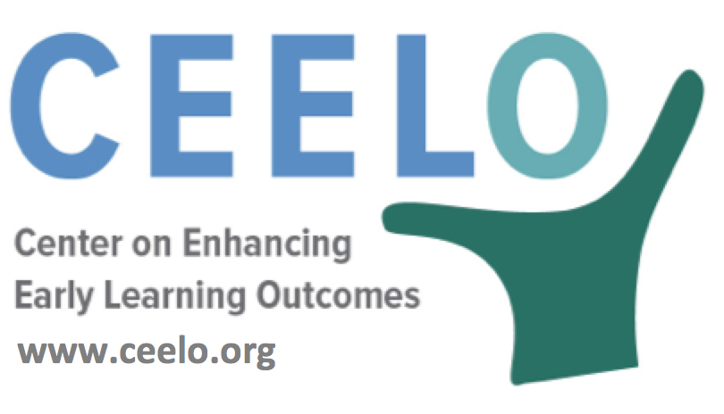
Why Quality Matters in Pre-K:
Investing

To be beneficial, early learning opportunities must be intentional, caring, and address the needs of each child. Providing such opportunities requires small class sizes and well-trained, experienced teachers. That is why much of the investment in Pre-K is dedicated to salaries and benefits, along with sustainable funding to enroll as many children as possible.
Expanding access for more children means adding classrooms, and each classroom usually requires at least two teachers, plus support staff to ensure high-quality programming. Maximum class size restrictions may also require new, additional classrooms to be created. In addition to supporting existing pre-K classrooms a state must identify adequate resources to ensure access to high-quality early education for all families interested in participating.

If pre-K classes operate longer than the elementary school day--and many do start earlier and end later--additional teachers may be necessary. To provide children with an engaging and educational experience, pre-K teachers and assistant teachers need ongoing professional development. Coaching is one of the most effective strategies to ensure high-quality teaching.
The coaching model can vary widely based on the number of classrooms assigned to each coach (caseload). Annual, ongoing professional development support requires the cost associated with the training as well as any substitute teacher costs to cover the classrooms in the teachers’ absence.
Did you know…
“Increased public investment in early learning is a pro-growth strategy that can reduce overall government expenditures.”
– W. Steven Barnett, Ph.D., senior co-director National Institute for Early Education Research, Rutgers University Graduate School of Education
- When government supports high-quality early childhood programs, evaluations find long-term effects improving important societal outcomes such as high-school graduation, years of education completed, earnings, crime and health.
- Rigorous cost-benefit analyses demonstrate that although high-quality programs are not cheap, the economic benefits can far outweigh the costs.
- Quality requires well-trained teachers using proven curricula to engage children in interactions that stimulate learning while being emotionally nurturing, and fostering engagement in and enjoyment of learning. Teaching is enhanced by systematic, sustained, in-classroom coaching and mentoring.
To learn more:
“Improving Public Financing for Early Learning Programs”
W. Steven Barnett Ph.D. and Jason T. Hustedt (April 2011)
nieer.org/policy-issue/policy-brief-improving-public-financing-for-early-learning-programs

