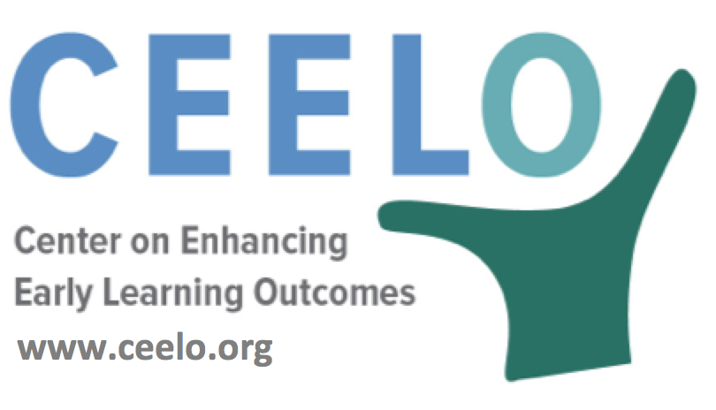

Why Quality Matters in Pre-K

Over the past few decades, a growing body of research suggests that participating in high-quality early childhood education programs can enhance children’s development, reduce achievement gaps at kindergarten entry, and even have long-term benefits in school and beyond. However, pre-K can only provide these benefits if a child’s classroom experience is high-quality.
What are the Elements of High Quality Pre-K?
Elements defining high quality associated with child outcomes include teacher credentials, training, and support; class size and student-to-teacher ratio; use and support of early learning and development standards; and a system of continuous quality improvement.
- Better education, training, and on-going support for teachers can improve their interactions with children, which can enhance children’s learning.
- With smaller classes and fewer children per teacher, children have greater opportunities for interaction with adults and can receive more individualized attention, resulting in a higher quality learning experience.
“Expansion of public pre-K is only a worthwhile public investment if children receive a high-quality education.”
– W. Steven Barnett, Ph.D., senior co-director National Institute for Early Education Research, Rutgers University Graduate School of Education
- Early learning and development standards offer programs guidance and establish the expectation that programs cover the full range of areas essential to children’s learning and development.
- Policies requiring strong state quality standards are essential, but it is also necessary to have a means of gauging whether specific pre-K programs are meeting those standards.
Did you know…
- High-quality early education is one of the best investments we can make with public dollars: an effective weapon against academic failure, high school dropout, crime and poverty and for a shared future that is healthier, more academically, socially, and economically successful.
- Access to high-quality early education remains scarce. Even many middle-income families can’t find or afford such an education before their children start kindergarten.
- The benefits of preschool–for children, families, and society at large–only accrue if preschool education truly is high-quality.
- Poor quality early childhood programs may actually widen the achievement gap.
To learn more:
How Much Can High-Quality Universal Pre-K Reduce Achievement Gaps?
Allison Friedman-Krauss, W. Steven Barnett, and Milagros Nores April 2016
nieer.org/research-report/much-can-high-quality-universal-pre-k-reduce-achievement-gaps

