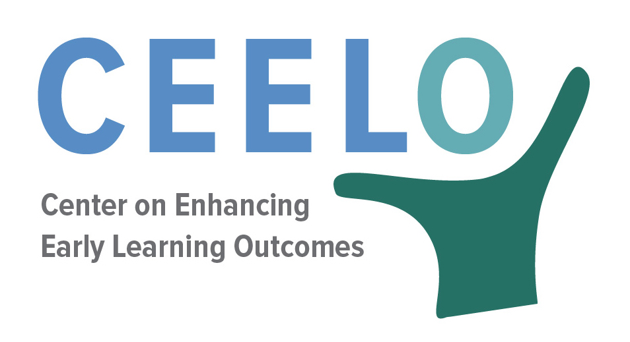

CEELO STATE EARLY LEARNING LEADERSHIP ACADEMY APPLICATION

CEELO’S Leadership Academy is yearlong professional development opportunity for leaders of early childhood policy and improvement initiatives in state education agencies (SEA) or other state early learning agencies (ELA). Each cohort of CEELO Fellows participate in a series of four in-person seminars with national experts on public sector leadership, engage in individualized coaching with a former senior-level state early childhood leader, complete a job-embedded policy-related leadership project, and form a peer learning community. Leadership Academy seminars will include interactive sessions on issues such as results based leadership, change management and systems thinking. Participants will also have the chance to shape the program and customize their learning to address their own priorities for leadership improvement and their states’ current and future early childhood policy challenges.
HOW TO APPLY
Complete the application below and send it, along with a current resume and your agency’s organization chart to info@ceelo.org. Applications are due by close of business on June 30, 2016. Finalists will be notified by September 1, 2016 of their selection. Finalists will have five days to accept the invitation to participate in the Leadership Academy.

SCORING OF APPLICATIONS
Part 1 – 40 points | word counts and point totals are noted in brackets for each of the three questions.
Part 2 – 40 points | job-embedded policy project and description.
Part 3 – 20 points | experience and background as reflected in applicant’s resume/CV.

Interviews and references will further inform the decision-making process, along with cohort characteristics such as mix of individuals, geography, and roles.

Part I: QUESTIONS FOR APPLICANTS [40 points]

- Why do you want to be part of the CEELO Leadership Academy? How will it help you enhance your leadership effectiveness? [Up to 200 words; 10 points.]

- Describe how you have used past career opportunities to improve your effectiveness in leading statewide efforts to improve early childhood (Birth-3rd grade) program quality and outcomes? [Up to 500 words; 10 points]

- Briefly describe how major early childhood policy and funding decisions are made in your office or agency and what role you have in informing and shaping these decisions. [Up to 500 words; 10 points]

- Describe an example of when you exercised leadership. Please note what you were trying to accomplish, why you think you were successful or unsuccessful, and what you think you could have done differently. (Up to 500 words; 10 points)

PART II. JOB-EMBEDDED POLICY PROJECT [40 points – up to 1000 words]

Each Leadership Academy fellow will complete a job-embedded policy-related project to advance their growth as a leader and apply concepts and strategies from Academy meetings and coaching. Each Leadership Academy meeting will include time for you to refine your project, share progress and reflections, and receive feedback from your coach, other Fellows and CEELO leadership.

- Identify a goal or responsibility within your current role that offers you an opportunity to apply the new leadership and management skills you will learn during the Leadership Academy.
- What results do you hope to achieve? What data informs your project? How will you know if your results have been achieved?
- What organizational and/or systemic challenges do you anticipate facing in implementing your project?
- How will the proposed project help you to expand and/or improve your leadership skills? Try to be as specific as possible in your response.

PART III. Additional Information [20 points]

1. Resume - Please attach your most current CV or resume. Reviewers will read your CV or resume to inform their understanding of your career progression and accomplishments to date.

2. Agency Reference - Please provide a professional reference from a colleague in your agency (for example, your supervisor, a colleague, a staff member you supervise.)

Name:
Relationship:
Telephone:
Email:

3. Outside Reference - Please provide a reference from a colleague outside the agency (preferably someone you have worked with to advance your vision for early childhood education.)

Name:
Relationship:
Telephone:
Email:

4. Agency Organization Chart - Please attach a current organizational chart for your agency or office. The diagram should clearly show where you are situated within your agency or you should provide a narrative sentence to provide that information.

PART IV. APPLICANT COMMITMENTS [No points – however, completion is required]

Applicant Signature
NOTE: By my signature below, I confirm that I meet the requirements of CEELO Leadership Academy applicants and commit to fully participating in the program.

Applicant’s Signature:

Print Name:
Date:

Supervisor Signature
NOTE: Your supervisor’s signature indicates permission to attend the yearlong CEELO Leadership Academy and to participate in out-of-state travel.

Supervisor Signature:

Print Name:
Date:

Agency Head Signature (e.g., superintendent, commissioner, Secretary)
NOTE: Your agency head’s signature indicates support for your participation in the CEELO Leadership Academy.

Agency Head Signature:

Print Name:
Date:

