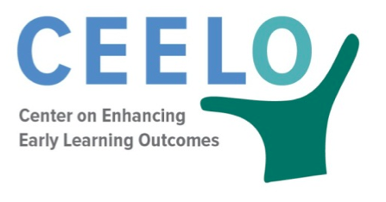
Peer Learning Community Reflection Tool

Purpose: This form is for Peer Learning Community members to reflect on the value of activities they have initiated, or engaged in. Results of the reflection and discussion can inform next steps; content, timing, and format of future meetings; and activities for action.

District Information
District:
PLC Topic:
PLC Participants:
Meeting dates:

Planning
What went well in the meeting(s)? What factors were important to these successes?

Were there any hurdles getting to this meeting or during the meeting? What solutions were considered?

What was learned and/or what actions were taken?

What are the next steps?

Additional Resources: The following resources provide additional information on peer learning communities.

Riley-Ayers, S. & Costanza, V.J. (2014). Professional Learning Academy: Supporting District Implementation of Early Childhood Policy. (CEELO FastFact). New Brunswick, NJ: Center on Enhancing Early Learning Outcomes.

Schilder, D., Clarke Brown, K., & Gillaspy, K. (2014). Peer Learning Community Guide (CEELO FastFact). New Brunswick, NJ: Center on Enhancing Early Learning Outcomes.

Clarke Brown, K. (2015). Peer Learning Communities. (CEELO Powerpoint Presentation. New Brunswick, NJ: Center on Enhancing Early Learning Outcomes.

This tool was developed by Shannon Riley- Ayers, Associate Research Professor, National Institute for Early Education Research.

