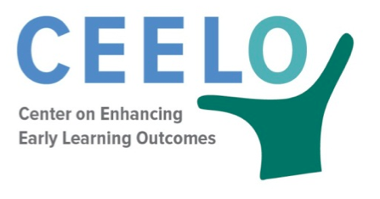
Peer Learning Community Planning Tool

Purpose: This form can assist Peer Learning Community members to plan future short-term and long-term activities and goals. This information can be used by the PLC facilitatotor to identify meeting goals and resources needed to support PLC actions.

District Information
District:
PLC Topic:
PLC Participants:
PLC Facilitator(s):
Date of first meeting:

Planning
PLC Starting Point (e.g., evidence document for teacher evaluation, assessment map, video taping teacher practice):

Rationale (The “why” behind this PLC):

PLC Goals (end product such as evidence document, assessment changes, increase in DAP in EC shown through video or classroom observation tools):

PLC Protocol:

Long Term Plan (if applicable):

Additional Resources: The following resources provide additional information on peer learning communities.

Riley-Ayers, S. & Costanza, V.J. (2014). Professional Learning Academy: Supporting District Implementation of Early Childhood Policy. (CEELO FastFact). New Brunswick, NJ: Center on Enhancing Early Learning Outcomes.

Schilder, D., Clarke Brown, K., & Gillaspy, K. (2014). Peer Learning Community Guide (CEELO FastFact). New Brunswick, NJ: Center on Enhancing Early Learning Outcomes.

Clarke Brown, K. (2015). Peer Learning Communities. (CEELO Powerpoint Presentation. New Brunswick, NJ: Center on Enhancing Early Learning Outcomes.

This tool was developed by Shannon Riley- Ayers, Associate Research Professor, National Institute for Early Education Research.

